域名： pillarlift

主营业务： 二手吊机和高空车业务

联系人： Sarah
Whatsapp: 152 1774 6038

公司介绍：

Shenzhen Pillarlift Co., Ltd. is a professional aerial work platform supplier and crane equipment exporter from China. Established in 2018, we supply scissor lifts, boom lifts, aerial work platforms, mobile cranes, truck cranes, crawler cranes, and lifting equipment accessories. With close cooperation with major Chinese brands, Pillarlift provides reliable new and used equipment, competitive prices, and professional export services for global customers.

推荐官网标题
Shenzhen Pillarlift Co., Ltd. | Aerial Work Platform & Crane Supplier

推荐副标题
Reliable Lifting Equipment, Cranes and Accessories from China

Meta Description
Shenzhen Pillarlift Co., Ltd. supplies aerial work platforms, cranes and accessories worldwide. Established in 2018, we work with leading Chinese brands to provide reliable new and used lifting equipment.

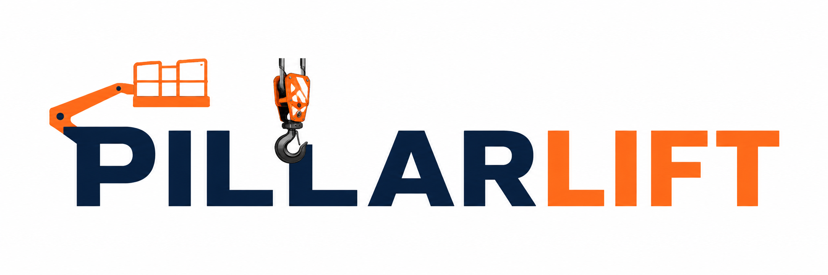

参考公司链接：

https://skylift.by/?utm_source=chatgpt.com

https://www.alibaba.com/product-detail/Aerial-Articulated-Boom-Work-Platform-30m_62348715185.html?spm=a2700.shop_pl.41413.23.dfd41dc2aTPY08

